Abstract-Submission-Template
UCRA2019 – International Conference on Unconventional Catalysis, Reactors and Applications, Zaragoza, October 16-18, 2019

ABSTRACT TITLE—CENTERED, CAPITALS AND BOLD

A. Author¹, B. Author², C. Author¹,

¹Institute of affiliation, Address, City, Country
²Institute of affiliation, Address, City, Country
e-mail@address.com

Keywords: xxxxxxxxxx

Body text is 12pt Times New Roman or similar, justified, single spaced. Page size is A4, left and right margins are 30 mm, top and bottom margins are 25 mm.

The abstract body text may contain at most 200 words. The abstract including images and tables may not exceed 1 page.

Table 1. Table caption.
Column | Column | Column
Table | Table | Table
Table | Table | Table

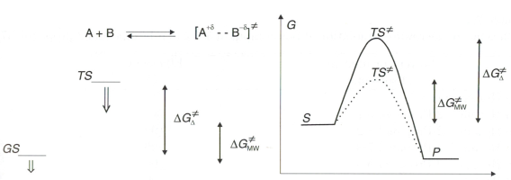
Fig. 1. Figure caption; centered when just one line, justified when more.

References
- Author, A., B. Author, Abbr. Journal Name, 2017, 12, 345–678.

