How to reach Zaragoza
Internatiional direct flights to Zaragoza are mainly with Ryanair from London-Stansted, Paris-Beauvais, Brussels-Charleroi. Check other direct flights.
http://www.aena.es/en/zaragoza-airport/index.html
Generally, it is more convenient to arrive in Madrid or Barcelona (Zaragoza is between them, about 300km far from either Madrid or Barcelona) and then continue on speed-train (less than 1.5 h) or bus (around 3.5 h).

From Madrid Barajas Airport to Zaragoza
By train:
From ATOCHA train station Madrid to Zaragoza-Delicias train station: High speed train (AVE), about 1h20min http://www.renfe.com/EN/viajeros/index.html. From MADRID-ATOCHA to ZARAGOZA-DELICIAS.
From the airport to ATOCHA train station 3 options:

- Suburban train C-1 or C-10 from Terminal T4 to ATOCHA (every 30 minutes it takes around 40 minutes now). Right now they are on works on some stations (see image below), the train is not direct to ATOCHA and you have to change track in CHAMARTIN to train C-2 or C-3 to ATOCHA.
If you arrive at Terminals T1,T2 or T3, there is a free bus inside the airport every 6-7 minutes and takes around 10-15 minutes to Terminal 2.

Usually the price of this train is included in your long distance AVE fare (Madrid-Zaragoza or Barcelona-Zaragoza), but ticket should be issued on the vending machines using the code on your AVE ticket. You may ask on the reception desk 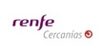 how to get the ticket in the machines, you should look in your ticket for the code “COMBINADO CERCANIAS”.
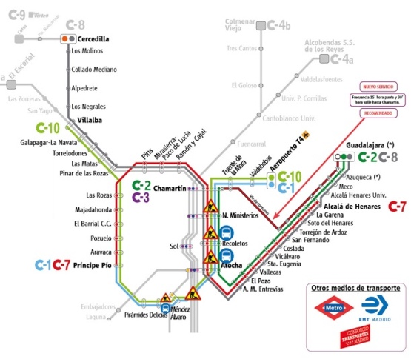

- By bus:
You have stops in the different terminals. It takes around 40 minutes. Cost 5€, you pay directly in the bus by cash or credit card.
Línea Exprés (line 203): Airport
Bus: http://www.aena.es/en/madrid-barajas-airport/city-buses.html.
- By metro:
You should change trains (2 different lines):
Line 8 from (Aeropuerto T1T2T3 or Aeropuerto T4) and stop Nuevos Ministerios.
Line 1 (direction: VALDECARROS) --> stop: ATOCHA-RENFE.
- By taxi:
It takes around 30 minutes although in rush hours, traffic could make it longer. The price is fixed 30€.
By bus:
Bus from Terminal 4 to Zaragoza-Delicias station. About 3.5-hour trip. https://www.alsa.es. From MADRID-AEROPUERTO BARAJAS T4 to ZARAGOZA (Zaragoza-Delicias bus and train station).
From Barcelona Airport to Zaragoza

By train:
From Barcelona SANTS train station to Zaragoza-Delicias train station: High speed train, about 1h40min http://www.renfe.com/EN/viajeros/index.html.

From the airport to SANTS train station 3 options:

- Suburbain train. Line R2 departs from Terminal 2, to SANTS (every 30 minutes it takes around 20 minutes).
If you arrive at Terminal 1, there is a free bus inside the airport every 6-7 minutes and takes around 10-15 minutes to Terminal 2.
Usually the ticket of this train is included in your fare Barcelona-Zaragoza, ask on the reception desk how to get the ticket in the machines, you should look in your ticket for the code “COMBINADO CERCANIAS”.
- By metro:
You should change trains (2 different lines):
Line 9S from (Aeropuerto T1 or Aeropuerto T2) and stop Collblanc.
Line 5 (direction: Vall d’Hebron) --> stop: Barcelona Sants.
- By taxi:
It takes around 30 minutes although in rush hours, there could be traffic jam. The price is fixed 39€.

By bus:
Bus from BARCELONA Nord station to Zaragoza. About 3.5-hour trip. https://www.alsa.es. From BARCELONA ESTACION NORD to ZARAGOZA (Zaragoza-Delicias bus and train station).
To get Barcelona Nord from the airport
Bus A2 to Plaza España
Metro L1 Plaza España to Barcelona Nord

INFORMATION ABOUT PRESENTATIONS
RELEVANT INFORMATION FOR SPEAKERS
- The authors must bring their presentations on a USB and pre-load them directly in the laptops provided by the organizers in the assigned Conference Room (A or B) at the beginning of each conference day.
- No individual laptops will be allowed for presentations. All contributors are kindly requested to check their presenting room and be there at least 15 minutes before the session begins. The presenters are kindly asked to introduce themselves to the Session Chair.
- Presentations should not exceed the time allocated. Keeping to the time limit is crucial to allow delegates to move from one session to another.
- Any presentation containing movies or video clips will require a copy of the video file (mp4 recommended). Presentation formats must be uploaded as PowerPoint files, including those presentations created on Apple Macintosh computers.
- Slides should be formatted for 16:9 ratio. When choosing fonts for your presentation please ensure they are supported by Microsoft Office.

RELEVANT INFORMATION FOR CHAIRPERSONS
Chairpersons are kindly requested to:
- Keep the sessions to the time allocated
- Give brief introductions on the speakers and their presented work
- Facilitate discussion by asking a number of pertinent questions, if necessary
- Be in the room with enough time in advance (at least 15 minutes) before the session begins and introduce themselves to the speakers
- If a presenter ends early or does not attend, please use the extra time for questions and remarks from the audience, the panel or yourselves. Please make sure that the following presentation is not started earlier than scheduled.
- In floor discussion, it is recommended to ask the participants to introduce themselves and repeat the questions to be sure that all the audience has heard

RELEVANT INFORMATION FOR POSTER SESSION
A space in Floor -1 of Palafox Hotel will be habilitated for poster display only on the 17th October (Poster session day only).
Dimensions for posters: A0 841 x 1189 mm
All posters must be removed at the end of the Poster Session at 19.30 PM. Upon arrival, required material for posting (stickers) will be provided by the local organization. Additional space will be available for storing the posters at the end of the session until the following day, if required. Local organization members will be available for poster enquiries on the Poster Session day.

